Lab description
Azure virtual network (VNet) peering is established between pairs of virtual networks. Once a peering connection is established, they appear as one network for connectivity purposes. Devices in each network can communicate with devices in the other network using private IP addresses. The two networks can be in different regions. This is referred to as global peering. Global peering traffic also stays in Microsoft's private backbone network, and does not traverse the public internet, meaning it provides superior security and performance.
This lab describes a scenario where peering can be used and also explains when peering cannot be used. You will create a virtual network, including resources in the network, and then create a peering connection with a pre-created virtual network. You will verify that the peering connection allows you to communicate between virtual networks using private addresses.

Lab Objectives
Upon completion of this lab, you will be able to:
- Configure Azure virtual networks and peering connections between networks
- Explain the situations when Azure virtual network peering applies
- Understand alternative Azure networking options when peering does not apply
- Use Azure VM serial console to test peering connectivity

Lab Prerequisites
You should be familiar with:
- Basic Azure concepts including the Azure Portal, VMs, and virtual networks

-
Environment before
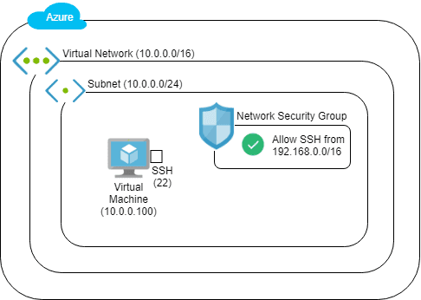
Environment after
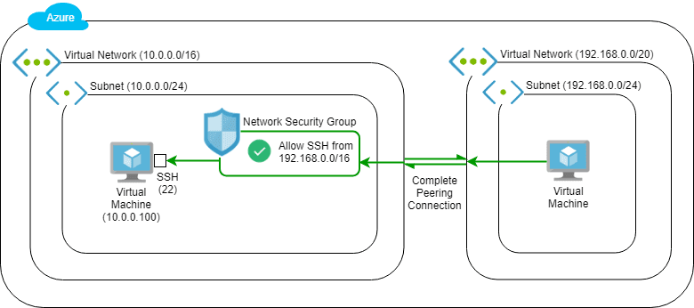

Lab steps
- Logging in to the Microsoft Azure Portal
- Understanding the Azure Virtual Networking Peering Scenario
- Creating the Development Department Network Resources
- Attempting to Make a Connection Using Serial Console
- Initiating the Virtual Network Peering Connection
- Testing the Virtual Network Peering Connection

